SYDNEY WESTERN CITY PLANNING PANEL

Panel No: | PPSSWC-154
DA Number: | DA/2021/1076/1.
Local Government Area: | Camden.
Development: | Construction of an extension to the Oran Park Town Centre Podium shopping centre to the northern side of Podium Way, known as Stage 3A including the extension of the retail complex, extension of the existing basement car park, construction of the eastern portion of Podium Way, and the reconfiguration of retail tenancies on the existing temporary at-grade car with associated site works and landscaping.
Street Address(es): | Lot 3 & 16 DP 270899  61 Podium Way & 351 Oran Park Drive, Oran Park
Applicant / Owner: | Greenfields Development Company No.2 – C/o Urbanco
Date of DA Lodgement: | 3 June 2021
Number of Submissions: | None.
Recommendation: | Approve with conditions.
Regional Development Criteria (Schedule 7 of State Environmental Planning Policy (State and Regional Development) 2011): | Development with capital investment value >$30 million.
List of All Relevant s4.15(1)(a) Matters: | - State Environmental Planning Policy (State and Regional Development) 2011.  - State Environmental Planning Policy (Sydney Region Growth Centres) 2006.  - State Environmental Planning Policy (Infrastructure) 2007.  - State Environmental Planning Policy (Major Infrastructure Corridors) 2020.  - State Environmental Planning Policy No 55 - Remediation of Land.  - Sydney Regional Environmental Plan No 20 - Hawkesbury-Nepean River.  - Camden Development Control Plan 2019.  - Oran Park Development Control Plan.
List all Documents Submitted with this Report for the Panel’s Consideration: | - Assessment report.  - State Environmental Planning Policy (Sydney Region Growth Centres) 2006 assessment table  - Oran Park Development Control Plan assessment table.  - Camden Development Control Plan assessment table.  - Recommended conditions.  - Proposed plans.  - Collated external referral responses.  - Site Photographs
Report Prepared By: | Clare Aslanis, Executive Planner
Report Date: | December 2021

Summary of Section 4.15 matters

Have all recommendations in relation to relevant s4.15 matters been summarised in the Executive Summary of the assessment report? | Yes.

Legislative Clauses Requiring Consent Authority Satisfaction

Have relevant clauses in all applicable environmental planning instruments where the consent authority must be satisfied about a particular matter been listed and relevant recommendations summarised in the Executive Summary of the assessment report? | Yes.

Clause 4.6 Contraventions to Development Standards

If a written request for a contravention to a development standard (Clause 4.6 of the Growth SEPP) has been received, has it been attached to the assessment report? | NA.

Special Infrastructure Contributions

Does the DA require Special Infrastructure Contributions (s7.24)? | Yes.

Conditions

Have draft conditions been provided to the applicant for comment? | Yes.

PURPOSE OF REPORT

The purpose of this report is to seek the Sydney Western City Planning Panel’s (the Panel’s) determination of a development application (DA) for the Oran Park Podium extension including temporary car parking and landscaped spaces.

The Panel is the consent authority for this DA as the capital investment value (CIV) of the development is $84,433,326. This exceeds the CIV threshold of $30 million prescribed in Schedule 7 of State Environmental Planning Policy (State and Regional Development) 2011.

SUMMARY OF RECOMMENDATION

That the Panel determine DA/2021/1076/1 for the Oran Park Podium extension including temporary car parking and landscaped spaces pursuant to Section 4.16 of the Environmental Planning and Assessment Act 1979 by granting consent subject to the conditions attached to this report.

EXECUTIVE SUMMARY

Council is in receipt of a DA for the extension of the Oran Park Podium retail centre including temporary car parking and landscaped spaces at 61 Podium Way and 351 Oran Park Drive, Oran Park.

The DA has been assessed against the Environmental Planning and Assessment Act 1979, the Environmental Planning and Assessment Regulation 2000, relevant environmental planning instruments, development control plans and policies.

A summary of the assessment of all relevant environmental planning instruments is provided below with a detailed assessment provided later in the report.

State Environmental Planning Policy (State and Regional Development) 2011. | The Panel is the consent authority for this DA as the development has a CIV of $84,433,326 which exceeds the CIV threshold of $30 million.
State Environmental Planning Policy (Sydney Region Growth Centres) 2006 | The proposal has been assessed against the provisions of the Growth Centres SEPP Appendix 1 – Oran Park and Turner Road Precinct Plan. An assessment table is attached to this report.
State Environmental Planning Policy (Infrastructure) 2007 (ISEPP). | The development is traffic generating development and referral to Transport for NSW (TfNSW) was required. TfNSW comments have been received and considered.
State Environmental Planning Policy (Major Infrastructure Corridors) 2020. | The proposal is immediately adjacent the gazetted rail corridor. Clause 11 required referral to TfNSW as the proposal involved excavation works within 25m of the future infrastructure corridor. No objections were raised by TfNSW.
State Environmental Planning Policy No 55 - Remediation of Land. | Council staff have assessed a preliminary site investigation (phase 1) contamination assessment submitted in support of the DA. Council staff are satisfied that the site is suitable for the development.
Sydney Regional Environmental Plan No 20 - Hawkesbury-Nepean River (SREP 20). | The development is consistent with the aim of SREP 20 (to protect the environment of the Hawkesbury-Nepean River system) and all of its planning controls.

The application was notified to surrounding properties and advertised for a 14 day period between 23 June and 6 July 2021. No submissions were received.

Based on the assessment, it is recommended that the DA be approved subject to the conditions attached to this report.

AERIAL PHOTO

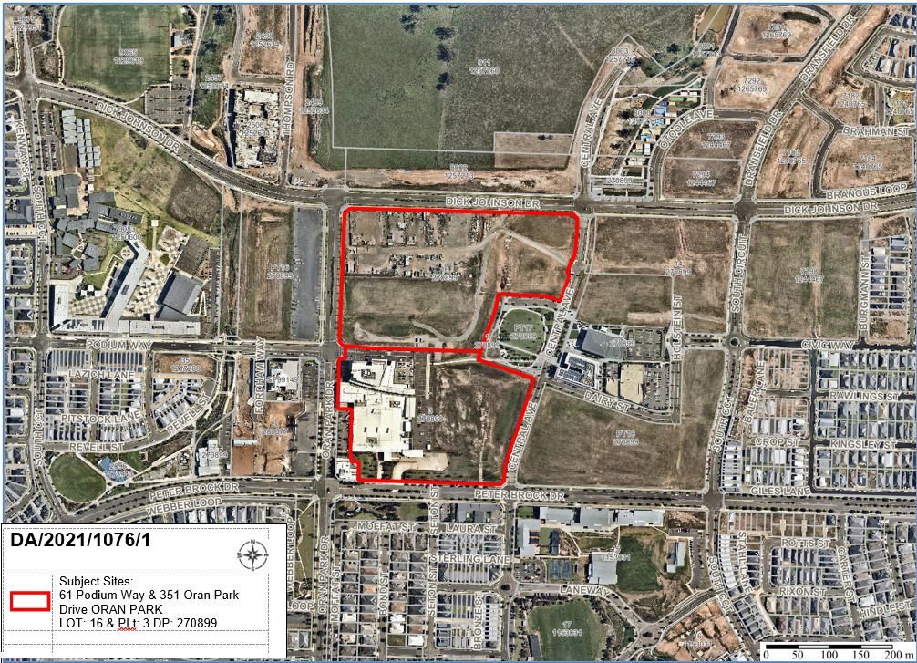
Figure 1: Aerial photograph

THE SITE

The subject site forms part of a large existing parcel which incorporates the existing Podium Shopping Centre within the Oran Park Town Centre and is legally described as Lot 3 & 16 DP 270899. The site is currently sloping from the southern edge towards Dick Johnson Drive at the northern boundary of the site.

Oran Park Town forms part of the South West Growth Centre and was rezoned in December 2007. Since rezoning, the Oran Park Town project has delivered over 2,500 residential homes, Stage 1 of the Town Centre retail component, Camden Council administration building and significant open space and recreational facilities.

The development site is primarily zoned B2 Local Centre under State Environmental Planning Policy (Sydney Region Growth Centres) 2006 – Appendix 1 Oran Park & Turner Road Precinct Plan (the Growth Centres SEPP). A portion of the site along the western boundary is zoned SP2 Infrastructure under State Environmental Planning Policy (Major Infrastructure Corridors) 2020, however no development is proposed on this part of the site.

The development site is bordered by the existing Podium shopping centre and approved extension to the south, Oran Park Drive to the west, Perich Park to east, and Dick Johnson Drive to the north.

The site is accessible to both local and regional vehicular movements given its proximity to Oran Park Drive, Peter Brock Drive and Dick Johnson Drive. Vehicular access to the site will be achieved via the existing access point on Oran Park Drive and Peter Brock Drive respectively with new access driveways for Oran Park Drive and Dick Johnson Drive.

There is an existing approval on the site for the expansion of the shopping centre toward the east. This approval is referred to as Stage 2 by the proponent. Stage 2A includes extension of Oran Park Podium Shopping Centre retail spaces, construction of two residential flat buildings (up to 12 storeys above Podium), construction of one commercial building, extension of basement car park, extension of Main Street with associated site works and landscaping. Stage 2B includes concept approval for future residential flat building envelopes fronting Central Avenue.

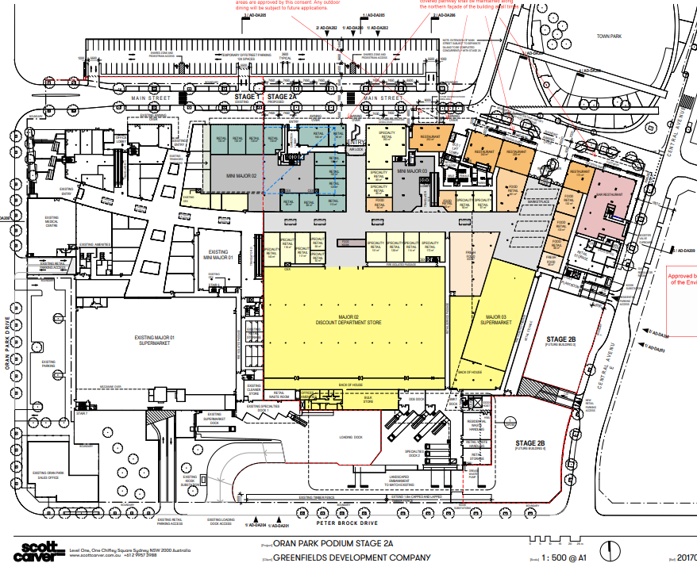
Figure 2: Approved site plan for the Oran Park Podium extension to the south of the subject development (Stage 2)
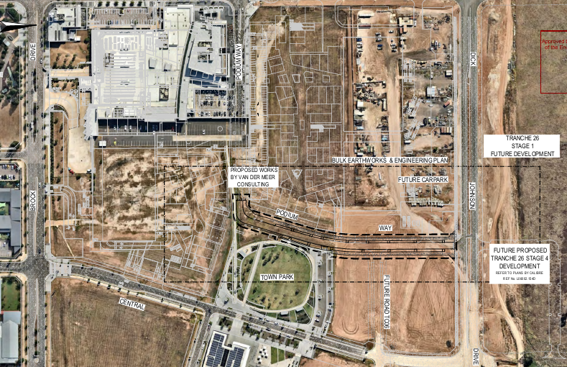
Figure 3: Approved plan showing extension of Podium Way to Dick Johnson Drive

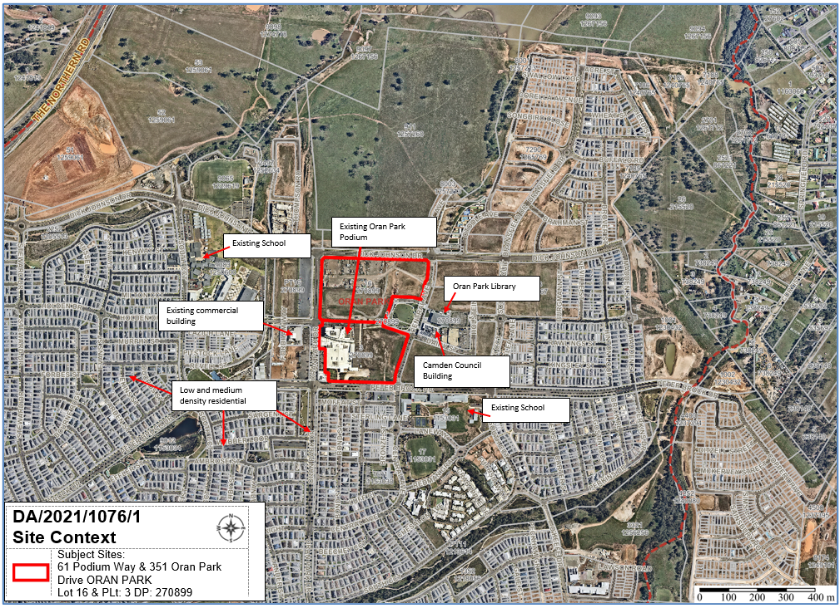
Figure 4: Site Context Plan

ZONING PLAN

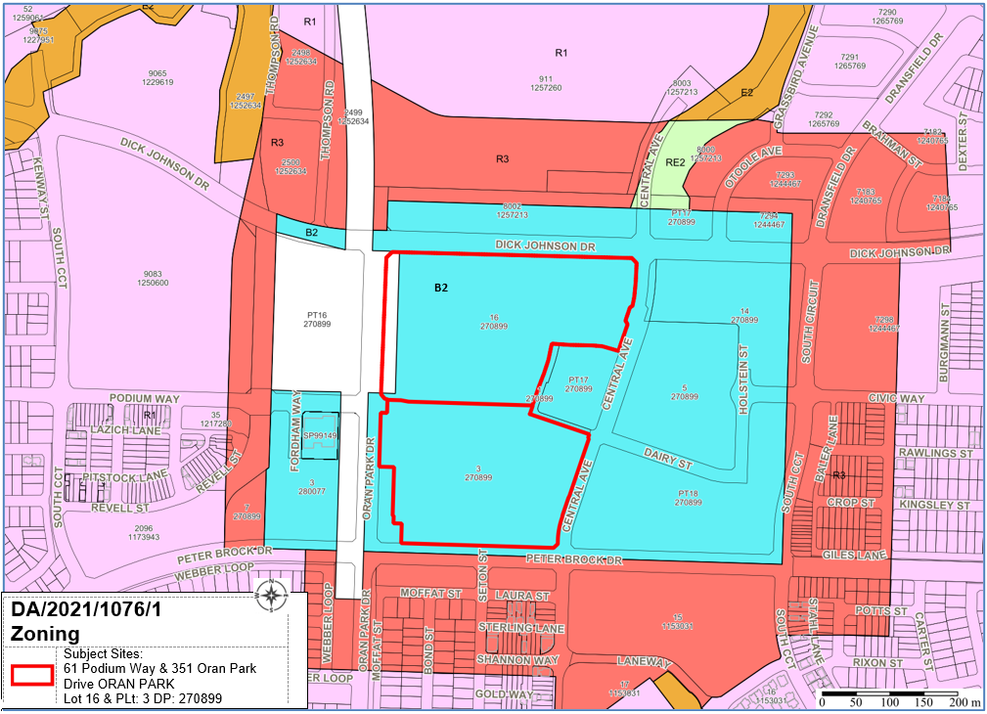
Figure 5: Site Zoning Plan

THE PROPOSAL

The subject application is seeking the use and development of land for the extension of Oran Park Podium Shopping Centre.

Specifically, the proposed development involves:

- Extension of the retail component to the north to accommodate small, medium and large scale retail uses, food hall and restaurant dining;

- Delivery of and additional 15,541sqm of retail floor space (Gross Leasable Floor Area) inclusive of Stage 1 car park infill area;

- A first floor Child Care Centre located centrally along Podium Way above the retail floor (fit-out and operation subject to a separate Development Application);

- Erection / reconfiguration of retail tenancies on the existing temporary at-grade car park on the southern side of Podium Way;

- Extension and minor reconfiguration of the existing basement car park to the north provide retail car parking areas;

- Delivery of the eastern portion of Podium Way;

- Streetscape landscaping works along the northern and southern side of Podium Way;

- Delivery of an outdoor terrace eating and dining area which will provide connectivity to temporary landscape works along Oran Park Drive (subject to a separate application);

- Temporary at-grade car park on the northern side of Podium Way; and

- Entry canopy connecting Stage 1 and Stage 3A retail entry points.

PANEL BRIEFING

Council staff briefed the Panel on the DA on 30 August 2021. The following discussion provides an assessment of how the issues raised by the Panel at the briefing have been addressed:

- Stage 3 is proceeding in advance of Stage 2. Pedestrian linkages along the “Podium Way” (Main Street) which are part of Stage 2 are anticipated to be complete before Stage 3 is constructed. This may need to be addressed in the conditions of any development consent.

A condition of consent is recommended to require construction of the Main Street extension, approved under DA/2018/1223/1 prior to the occupation of any of the retail tenancies created by the subject proposal.

- The Panel shares the Council’s concerns about the presentation to Dick Johnson Drive with the retail uses elevated to the first floor over car parking. Notably the DCP which specifically addresses the Oran Park Town Centre anticipated sleeved parking behind the building, with an active shopfront along Dick Johnson Drive. The pedestrian connection between the station and the expanding town to the north east would seem to benefit from the DCP vision being more closely adhered to. As a greenfield site, the planning for this town centre should be of a high quality to deliver a meaningful civil location.

The applicant has provided additional information regarding the presentation to Dick Johnson Drive to demonstrate the street activation envisaged for the broader development, which is attached as an appendix to this report.

Future Stage 5 is planned to wrap around the corner of Oran Park Drive and Dick Johnson Drive as depicted below. This is likely to occur following the completion of the gazetted future rail.

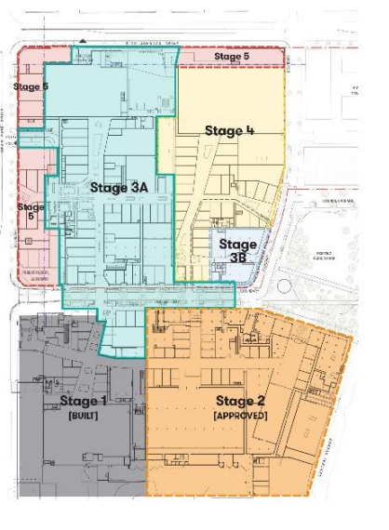
Figure 6: Overall masterplan for the subject site (noting Stage 5 to Dick Johnson Drive)

The information provided draws comparison to the Rouse Hill Town Centre where exposed basement car parking and loading docks were exposed and screened by landscaping but eventually developed further. The final built form outcome results in more positively activated street frontages.

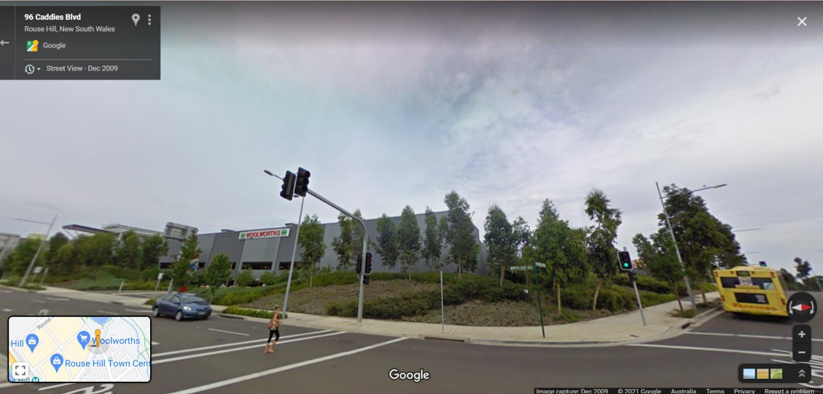
Figure 7: Google Street image from the corner of White Hart Drive and Civic Way, Rouse Hill in 2009. Noting new mature tree plantings to screen exposed car parking.

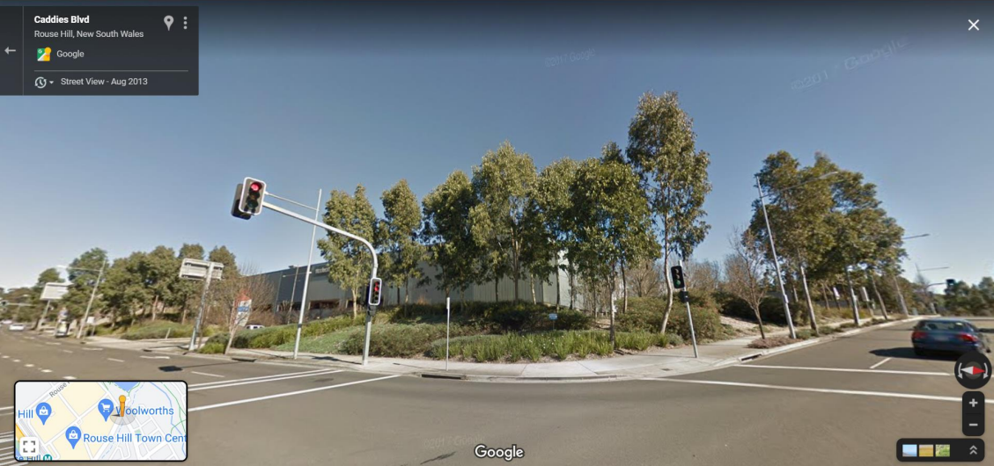
Figure 8: Google Street image from the corner of White Hart Drive and Civic Way, Rouse Hill in 2014. Noting established tree plantings to screen exposed car parking.

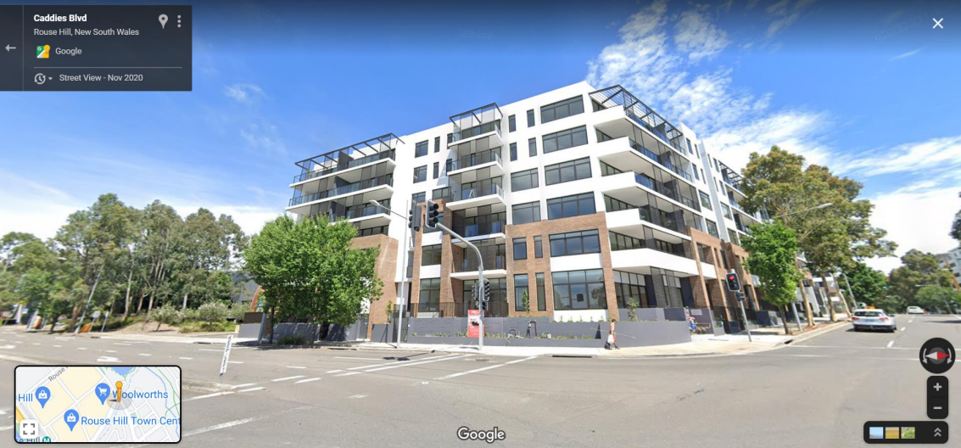
Figure 9: Google Street image from the corner of White Hart Drive and Civic Way, Rouse Hill in 2019. Noting activated street frontage.

Similarly, the subject proposal anticipates that future stages of the development will be able to address the activation of the Dick Johnson Drive interface. Temporary landscaped screening will ensure an attractive streetscape until future stages are constructed.

- The planning for the pedestrian linkages should be designed with place making objectives in mind, so that they emerge as more than shopping mall thoroughfares. Delivering meaningful interaction with the development while the other stages are completed is also important.

Pedestrian linkages to Main Street/Podium Way provide a high level of pedestrian amenity. Other pedestrian linkages on the eastern and western sides of the subject site are proposed to be temporary in nature pending future stages, including Stage 5 that will link to the future rail station and Stages 3b and 4 that are subject to current planning proposals for the Oran Park Town Centre.

Any new planning proposal will ensure that quality pedestrian linkages to and from the future rail, future leisure centre, open spaces and civic uses are provided. The subject development application ensures that those linkages are accounted for in the current design without deviating from the current vision for the town centre.

The temporary spaces are proposed to provide amenity through soft/hard landscaping and public art to achieve positive interfaces until future stages are completed.

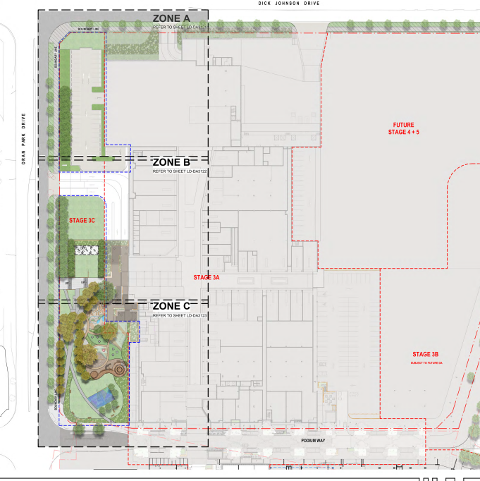
Figure 10: Landscaped interface to Oran Park Drive that is currently under assessment in a separate development application.

ASSESSMENT

Environmental Planning and Assessment Act 1979 - Section 4.15(1)

In determining a DA, the consent authority is to take into consideration such of the following matters as are of relevance to the development the subject of the DA:

(a)(i) the provisions of any environmental planning instrument

The environmental planning instruments that apply to the development are:

- State Environmental Planning Policy (State and Regional Development) 2011.
- State Environmental Planning Policy (Sydney Region Growth Centres) 2006.
- State Environmental Planning Policy (Infrastructure) 2007.
- State Environmental Planning Policy (Major Infrastructure Corridors) 2020.
- State Environmental Planning Policy No 55 - Remediation of Land.
- Sydney Regional Environmental Plan No 20 - Hawkesbury-Nepean River.

State Environmental Planning Policy (State and Regional Development) 2011 (SRD SEPP)

The SRD SEPP identifies development that is State significant or regionally significant development.

The Panel is the consent authority for this DA as the CIV of the development is $84,433,326. This exceeds the CIV threshold of $30 million pursuant to Schedule 7 of the SRD SEPP.

State Environmental Planning Policy (Sydney Region Growth Centres) 2006

Site Zoning

The site is zoned B2 Local Centre pursuant to Clause 2.2 of the Growth Centres SEPP – Appendix 1.

Land Use Definitions

The development comprises a number of different uses, which can be defined as:
- Retail Premises
- Business Premises
- Office premises
- Centre Based Child Care Facility.

Permissibility

All of the above land uses are listed as permitted with consent within the B2 Local Centre zone pursuant to the land use table in the Growth Centres SEPP – Appendix 1.

Planning Controls

An assessment table in which the development is considered against the Growth Centre SEPP’s is provided as an attachment to this report.

State Environmental Planning Policy (Infrastructure) 2007 (ISEPP)

The ISEPP aims to facilitate the effective delivery of infrastructure across the State.

The DA was referred to Transport for NSW (TfNSW) for comment pursuant to Clause 104 of the ISEPP as the development is classed as traffic generating development being that it exceeds the size or capacity specified in Schedule 3 of the ISEPP.

TfNSW raised no objection to the development.

State Environmental Planning Policy (Major Infrastructure Corridors) 2020

Part of the site is zoned SP2 Infrastructure under this instrument. The proposal is entirely contained within the portion of the site that is not affected by this zoning. However, Clause 11 of this SEPP requires any development that involves the penetration of ground to a depth of 2m below ground level within 25m of the future infrastructure corridor to be referred to TfNSW for review.

The proposal was referred to TfNSW who raised no objection to the development.

State Environmental Planning Policy No 55 - Remediation of Land (SEPP 55)

SEPP 55 provides a State-wide planning approach to the remediation of contaminated land.

Clause 7 of SEPP 55 requires the consent authority to consider if the site if contaminated. If the site is contaminated, the consent authority must be satisfied that it is suitable in its contaminated state for the development. If the site requires remediation, the consent authority must be satisfied that it will be remediated before the land is used for the development. Furthermore, the consent authority must consider a preliminary contamination investigation in certain circumstances.

The applicant has submitted a preliminary site investigation (phase 1) in support of the DA. This assessment found the site to be suitable for the development from a contamination perspective. Council staff have reviewed the assessment, agree with the findings and are satisfied that the site is suitable for the development.

A standard unexpected finds contingency condition is recommended that requires any contamination found during construction to be managed in accordance with Council's Management of Contaminated Lands policy.

Sydney Regional Environmental Plan No 20 - Hawkesbury-Nepean River (SREP 20)

SREP 20 aims to protect the environment of the Hawkesbury-Nepean River system by ensuring that the impacts of future land uses are considered in a regional context.

The development is consistent with the aim of SREP 20 and all of its planning controls. There will be no detrimental impacts upon the Hawkesbury-Nepean River system as a result of the development. Appropriate erosion, sediment and water pollution control measures have been proposed as part of the development.

(a)(ii) the provisions of any proposed instrument that is or has been the subject of public consultation under this Act and that has been notified to the consent authority (unless the Secretary has notified the consent authority that the making of the proposed instrument has been deferred indefinitely or has not been approved)

Draft Environment State Environmental Planning Policy (Draft Environment SEPP)

The development is consistent with the Draft Environment SEPP in that there will be no detrimental impacts upon the Hawkesbury-Nepean River system as a result of it.

Draft Remediation of Land State Environmental Planning Policy (Draft Remediation SEPP)

The development is consistent with the Draft Remediation SEPP in that the applicant has submitted a preliminary site investigation (phase 1) that concludes that the site is suitable for the development from a contamination perspective.

(a)(iii) the provisions of any development control plan

Oran Park Development Control Plan 2007

An assessment table in which the development is assessed against the Oran Park DCP is provided as an attachment to this report.

The variation identified in the assessment table is addressed below:

Proposed Variation – Environmentally Sustainable Development Principles - Green Star Rating

The applicant has not submitted certification that the building’s design has reached a minimum 4 Green Star rating from the Green Council of Australia. The applicant has also indicated they are unwilling to accept the requirement to obtain this certification for the Green Council of Australia as part of the conditions of consent.

To assess sustainability outcomes, the proponent has adopted the site-specific sustainability criteria which were prepared for ‘Attachment B’ in the DCP in consultation with the Department of Planning, Landcom, Camden Council and the Oran Park Town project team. The sustainability controls are considered more appropriate to the Western Sydney context of the subject site than adopting a standardised target of the 4 Star Green Star rating.

A detailed Environmental Sustainability Development Report has been prepared which demonstrates that the proposed building either meets, or exceeds all of the sustainability measures and criteria listed in the Sustainability DCP which forms Attachment B. The report also addresses compliance with Section J of the BCA, which sets out a range of measures that requires buildings to be constructed to reduce greenhouse gas emissions.

The report meets the objectives and intent of the sustainability measures of the Part B DCP, being to ensure the new commercial building achieves an appropriate level of environmentally sustainable design.

Requiring strict compliance with the private Green Star system is not considered warranted in this circumstance. All buildings delivered within the Oran Park Town Centre to date have successfully adopted and implemented the Part B DCP Sustainability Measures.

Consequently, it is recommended that the Panel support this proposed variations to the Oran Park DCP 2007.

Camden Development Control Plan 2019 (Camden DCP)

An assessment table in which the development is assessed against the Oran Park DCP is provided as an attachment to this report.

(a)(iiia) the provisions of any planning agreement that has been entered into under section 7.4, or any draft planning agreement that a developer has offered to enter into under section 7.4

The site falls within land which is subject to the Oran Park Urban Release Area Voluntary Planning Agreement (VPA), signed in September 2011.

The Oran Park VPA provides for infrastructure and associated facilities within the Oran Park Town project, in lieu of payments under the Oran Park & Turner Road Precinct Contributions Plan.

The site is located within Stage G, as identified in the VPA. A number of facilities are required to be delivered prior to progression of the overall Oran Park precinct development. The application has been referred to Council’s Contributions Team, who have indicated that all relevant deliverables in Stage G have been completed and raise no objection to the application subject to the recommended conditions of consent.

(a)(iv) the regulations (to the extent that they prescribe matters for the purposes of this paragraph)

The Environmental Planning and Assessment Regulation 2000 prescribes several matters that are addressed in the conditions attached to this report.

(b) the likely impacts of the development, including environmental impacts on both the natural and built environments, and social and economic impacts in the locality

As demonstrated by the assessment, the development will not have any unreasonable adverse impacts on either the natural or built environments, or the social and economic conditions in the locality.

Traffic Impacts
Oran Park Podium is a master planned site and the local road network has been designed and constructed to cater for the delivery of the proposed land use. A traffic report was prepared for the proposal which concludes that the traffic impacts resulting from the proposal are acceptable and within the limits of the existing street network.

The application was referred to TfNSW as Traffic Generating Development. TfNSW raised no objection, with no specific conditions recommended.

Parking impacts
The proposal provides 1,325 car parking spaces for the entire development. The car parking provided exceeds the minimum required under the Camden Development Control Plan 2019.

It is noted that the temporary car parking area on the northern side of Main Street contains an additional 87 car parking spaces. These spaces will be used for construction vehicles as well as overflow for the Podium Shopping Centre until such time as future stages are completed.

Noise impacts
The proposal has been assessed against the relevant noise criteria and no concerns are raised with regard to the noise generated by the proposal. The more intense land uses and street activation occurs at the southern end of the site where there is less residential development existing and envisaged. This limits the potential nuisance caused by noise from the retail and restaurant users.

The loading dock area at the northern end of the site has been assessed for noise impacts on nearby residents. The setback into the site increases the distance between the source of noise and any future residents, which would also be separated by Dick Johnson Drive. Furthermore, the addition of a landscape buffer, located on the property boundary, mitigates noise leaving the site.

Visual impacts
The proposal has incorporated a number of architectural features to appropriately break up the building mass through articulation, landscaping and building materials. The variation in building heights across the site also contributes to improved visual interest.

The building design and scale are an appropriate urban design outcome for the Oran Park Town Centre with surrounding buildings providing a transition to lower and medium density residential developments. All ground floor tenancies provide a human scale through awning heights, street tree plantings and footpath widths to ensure that the development is inviting and visually unobtrusive.

The planned future stages will also present built form to the street frontages.

(c) the suitability of the site for the development

As demonstrated by the above assessment, the site is considered to be suitable for the development.

(d) any submissions made in accordance with this Act or the regulations

The application was notified to surrounding properties and advertised for a 14 day period between 23 June and 6 July 2021. No submissions were received.

(e) the public interest

The public interest is served through the detailed assessment of this DA under the Environmental Planning and Assessment Act 1979, the Environmental Planning and Assessment Regulation 2000, environmental planning instruments, development control plans and policies. Based on the above assessment, the development is consistent with the public interest.

EXTERNAL REFERRALS

The external referrals undertaken for this DA are summarised in the following table:

External Referral | Response
Transport for NSW | No objections raised.
NSW Police – Camden Local Area Command | No objections raised, subject to recommended conditions of consent.

Appropriate conditions are included in the recommended conditions of consent.

FINANCIAL IMPLICATIONS

This matter has no direct financial implications for Council.

CONCLUSION

The DA has been assessed in accordance with Section 4.15(1) of the Environmental Planning and Assessment Act 1979 and all relevant instruments, plans and policies. The DA is recommended for approval subject to the conditions attached to this report.

RECOMMENDED
That the Panel approve DA/2021/1076/1 for the Oran Park Podium extension at 61 Podium Way and 351 Oran Park Drive, Oran Park subject to the conditions attached to this report.

